Grid

Central Hub - you can connect various machines and run the test cases parallel . This saves lot of time. You are having 1000 test cases .

Each machine is called node .

Hub – runs on 4444 . It connects to node with port 5000 . With each node there is a port assigned

Node A – 5000

Node B – 5001

Node C – 5002

On one node ,you can open up single browser

1 node – Mozilla

1 Node – IE

1 Node – Chrome

Parallely I run single testcase on multiple machines

10 test cases – Node A – 3 test cases , Node B – 3 test cases , Node C – 4 test cases.

You can have multiple browsers on 1 node . You can have multiple browsers running parallely on one node or serially on one node.

Similarly on one PC you can have multiple nodes. In each node , you can have multiple browsers and run the test cases parallel or serially.

Node is a one which opens up on a port .

Single PC I can make a hub and single PC I can open up 5 different nodes. On each node I can open up multiple browsers.

For grid – we need to download the stand alone jar file for the web driver.

Step 1 – u need to make my machine as hub and start it.

* **To start a hub:**

**C:\>java –jar selenium-server-standalone-2.29.0.jar – role hub**

**By default ,hub starts on port 4444**

* **To start a node**

**C:\>Java -jar selenium-server-standalone-2.29.0.jar –role webdriver –hub (space)** [**https://localhost:4444/grid/register -port 5556**](https://localhost:4444/grid/register%20-port%205556)

**Open node on another command prompt**

**Role should be registered with hub.**

**Got to hub console**

**You will see 1 node is started .**

**By default – 5 mozilla ,5chrome and 1 IE**

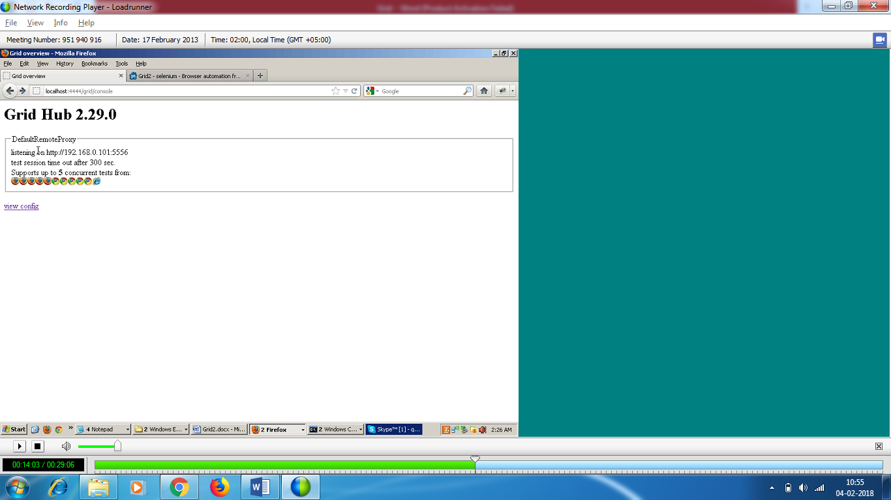

You can decide the no of browsers on one node.

Max session and max instances

* Suppose I need to open only firefox only on node

**C:\>Java -jar selenium-server-standalone-2.29.0.jar –role webdriver –hub (space)** [**https://localhost:4444/grid/register -port 5556**](https://localhost:4444/grid/register%20-port%205556) **-browser browsername=firefox**

Kill the node control+c

Open up the node

Refresh the console , you will see only firefox.

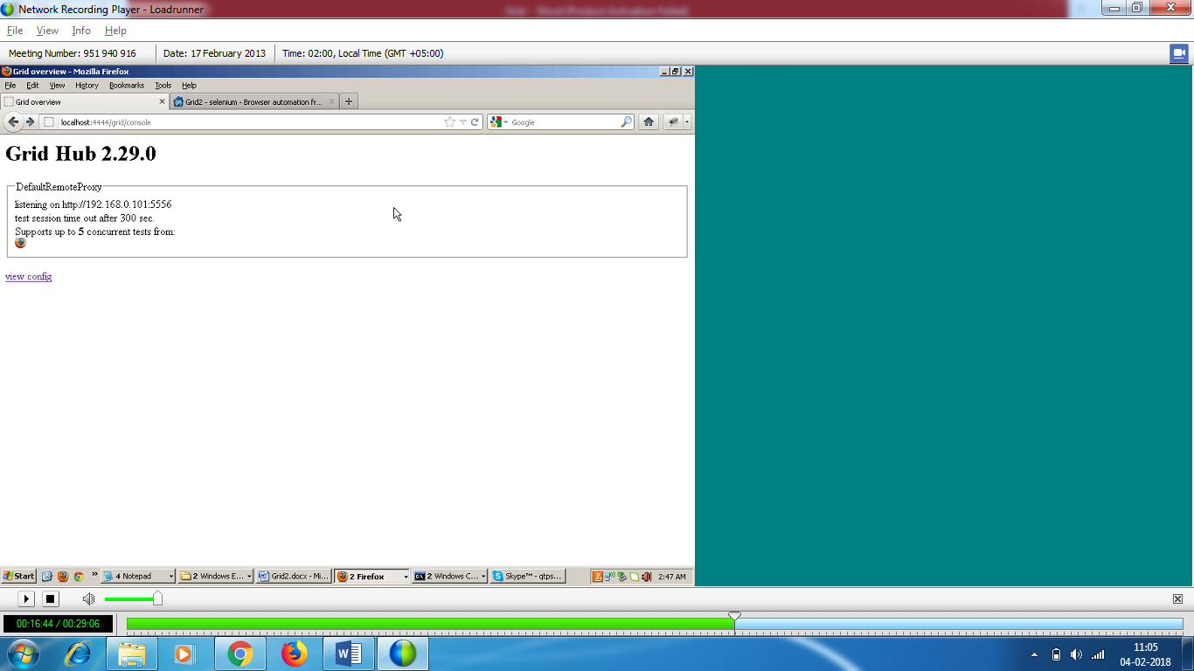

Suppose I need ff and chrome

**C:\>Java -jar selenium-server-standalone-2.29.0.jar –role webdriver –hub (space)** [**https://localhost:4444/grid/register -port 5556**](https://localhost:4444/grid/register%20-port%205556) **-browser browserName=firefox -browser browserName=chrome –browser browserName=iexplore**

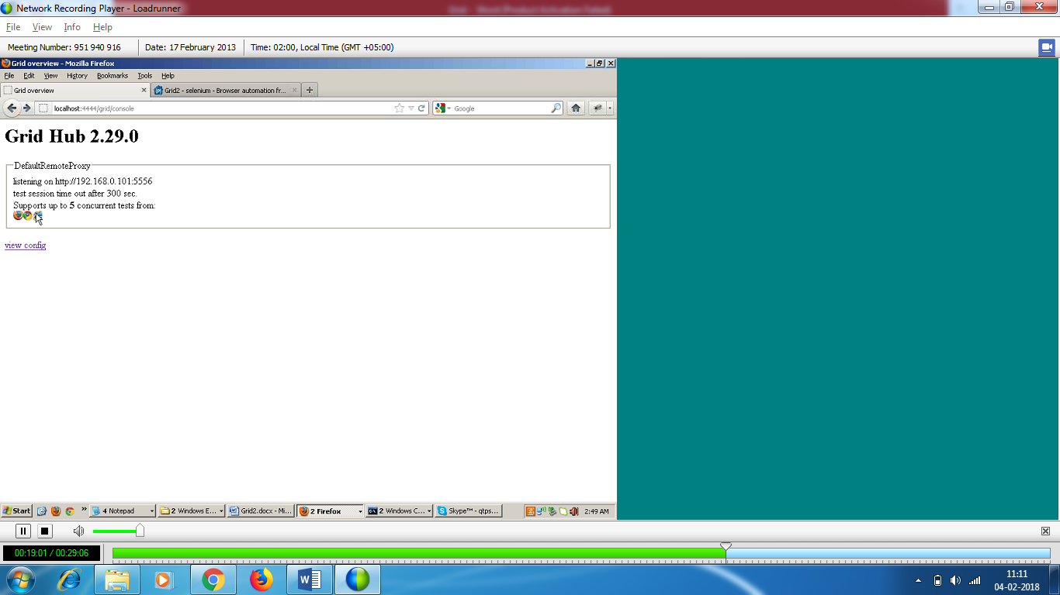

You can run the test cases parallely or serially on these browsers

**Max Instances**

**C:\>Java -jar selenium-server-standalone-2.29.0.jar –role webdriver –hub (space)** [**https://localhost:4444/grid/register -port 5556**](https://localhost:4444/grid/register%20-port%205556) **-browser browserName=firefox,-maxinstance=2 -browser browserName=chrome –browser browserName=iexplore**

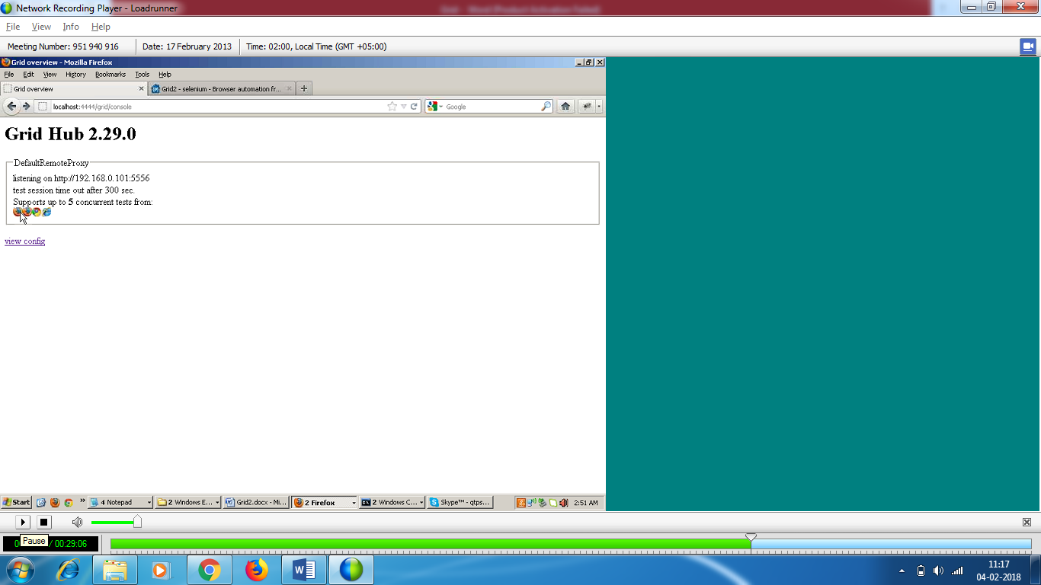

**C:\>Java -jar selenium-server-standalone-2.29.0.jar –role webdriver –hub (space)** [**https://localhost:4444/grid/register -port 5556**](https://localhost:4444/grid/register%20-port%205556) **-browser browserName=firefox,-maxinstance=2 -browser browserName=chrome,-maxinstance=3 –browser browserName=iexplore,-maxinstance=2**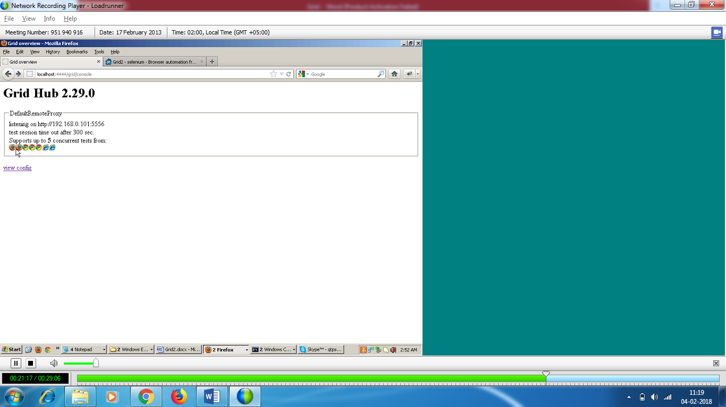

**Max session**

* Supports upto 5 concurrent browsers – what does this mean?

In one session , I can support upto 5 browsers

**C:\>Java -jar selenium-server-standalone-2.29.0.jar –role webdriver –hub (space)** [**https://localhost:4444/grid/register -port 5556**](https://localhost:4444/grid/register%20-port%205556) **-browser browserName=firefox,-maxinstance=2 -browser browserName=chrome,-maxinstance=3 –browser browserName=iexplore,-maxinstance=2 –maxsession 3**

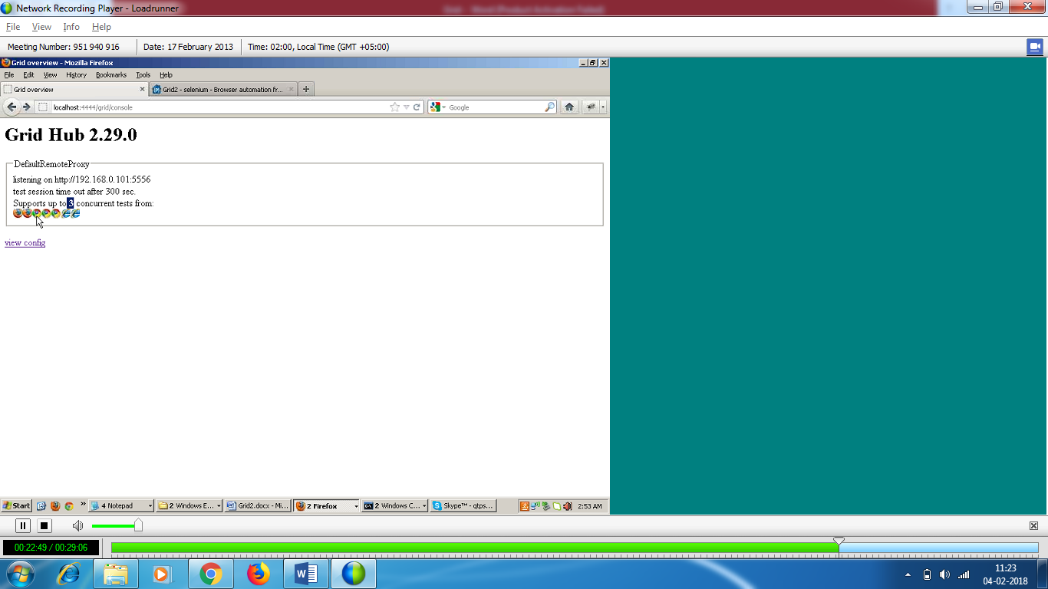

**At one time / session , max no of browsers available are 3**

You can open 2 ff and 1 ie / 2 chrome and 1 ff . It depends on your choice.

* Create another node one same machine

Open another command prompt (change the port no)

**C:\>Java -jar selenium-server-standalone-2.29.0.jar –role webdriver –hub (space) https://localhost:4444/grid/register -port 55567 -browser browserName=firefox,-maxinstance=1 -browser browserName=chrome,-maxinstance=1 –browser browserName=iexplore,-maxinstance=1 –maxsession 1**

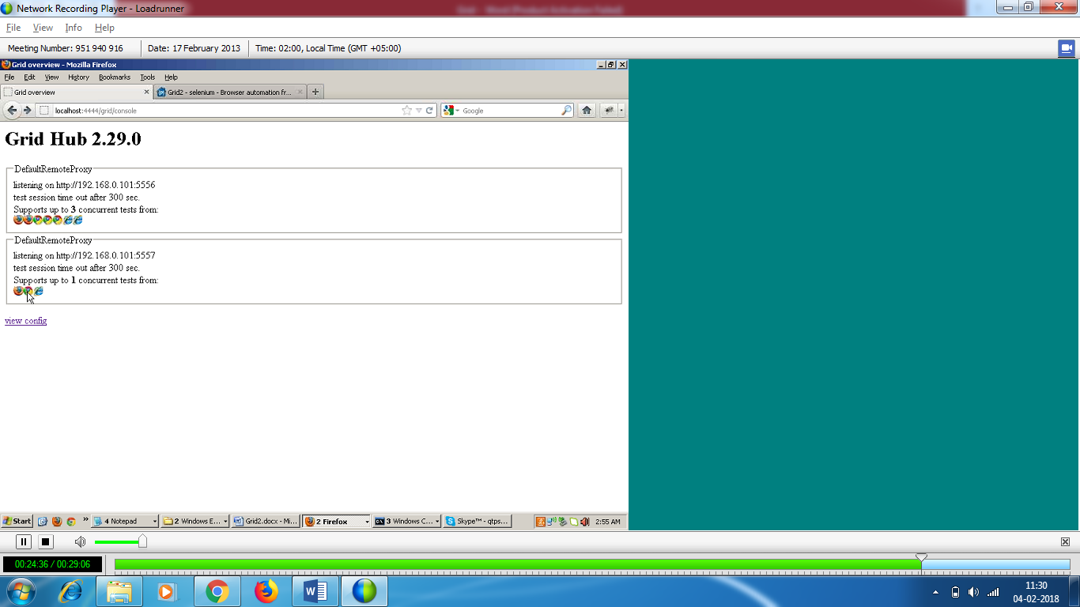

**TEST CASE IMPLEMENTATION**

* **In grid , you need to use remote web driver**
* **hub and node on same machine**
* **On this node , I will implement single test case**
* **I will serially and parallel run on multiple browsers.**

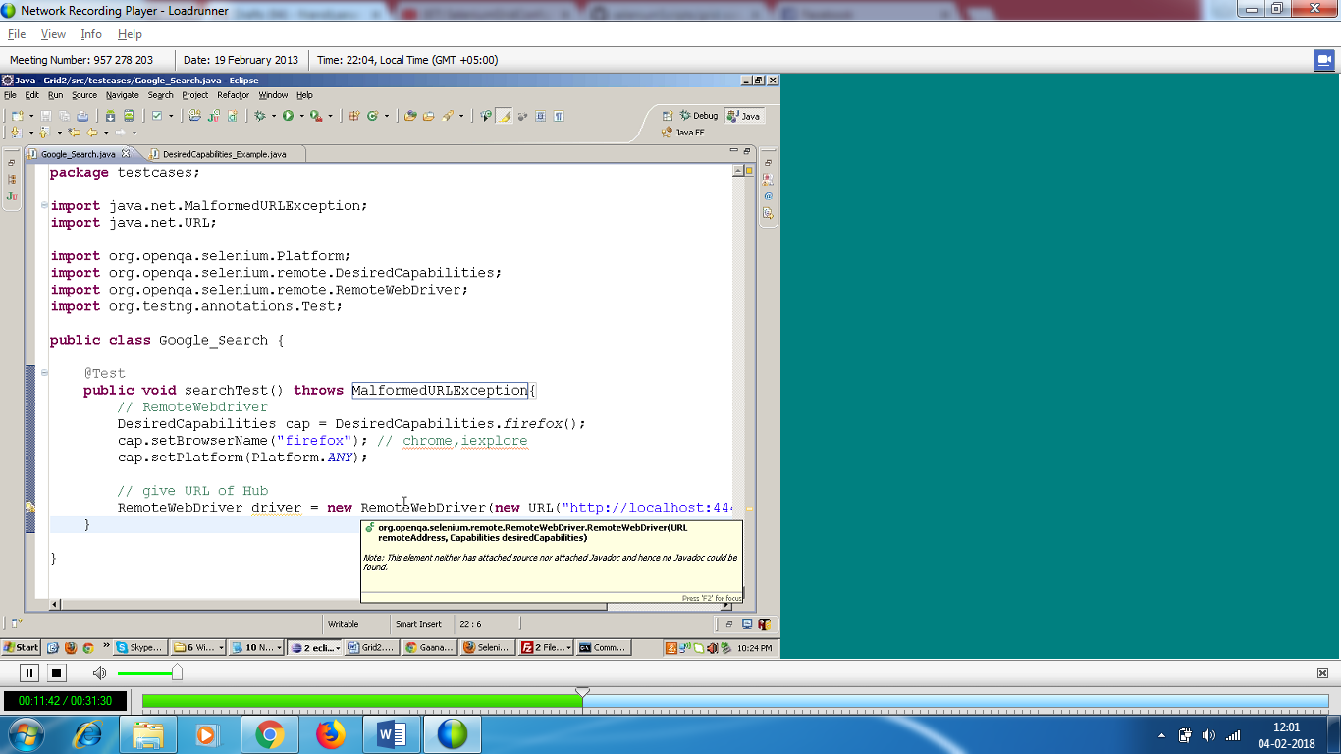

At one node , you can work with multiple browsers.

* While working with chrome and IE , you need to give exe path
* **C:\>Java – Dwebdriver.chrome.driver=H:\chromedriver.exe -jar selenium-server-standalone-2.29.0.jar –role webdriver –hub (space) https://localhost:4444/grid/register -port 55567 -browser browserName=firefox,-maxinstance=1 -browser browserName=chrome,-maxinstance=1 –browser browserName=iexplore,-maxinstance=1 –maxsession 1**

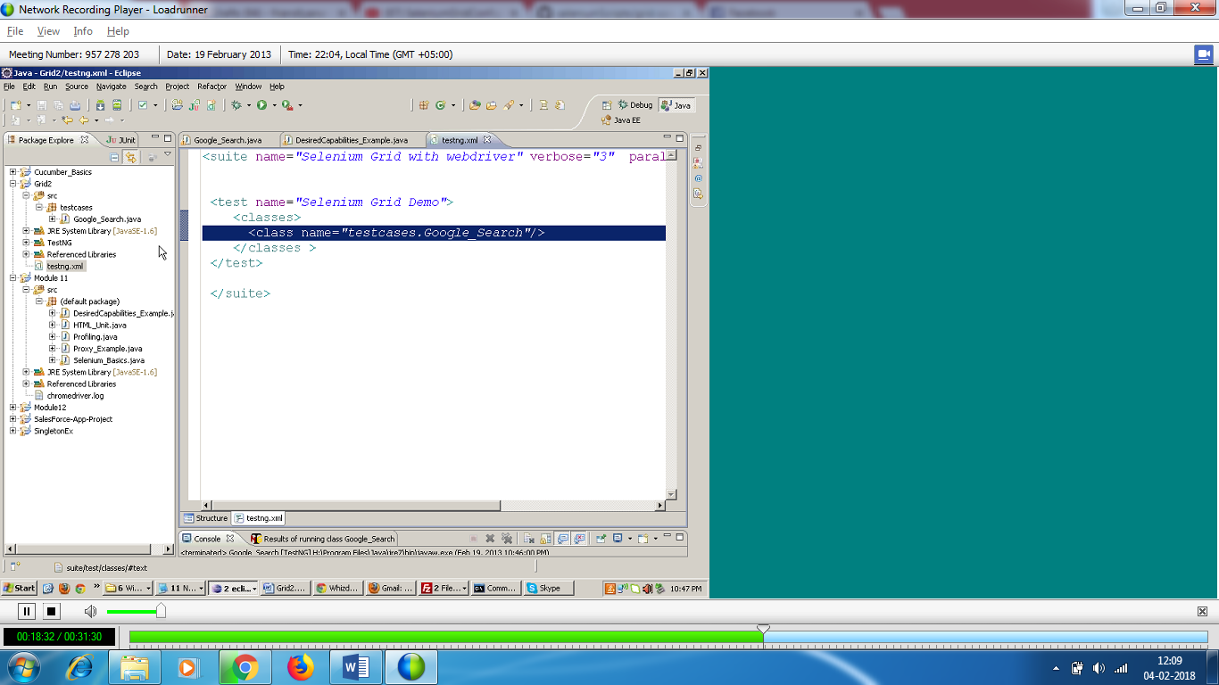

* **Start a hub**
* Create a node

**C:\>Java –Dwebdriver.chrome.driver=H:\chromedriver.exe -jar selenium-server-standalone-2.29.0.jar –role webdriver –hub (space)** [**https://localhost:4444/grid/register -port 5556**](https://localhost:4444/grid/register%20-port%205556) **-browser browserName=firefox,-maxinstance=2 -browser browserName=chrome,-maxinstance=3 –browser browserName=iexplore,-maxinstance=1 –maxsession 3**

* 1 hub and 1 node

The test has run on ff and u see greyed out.

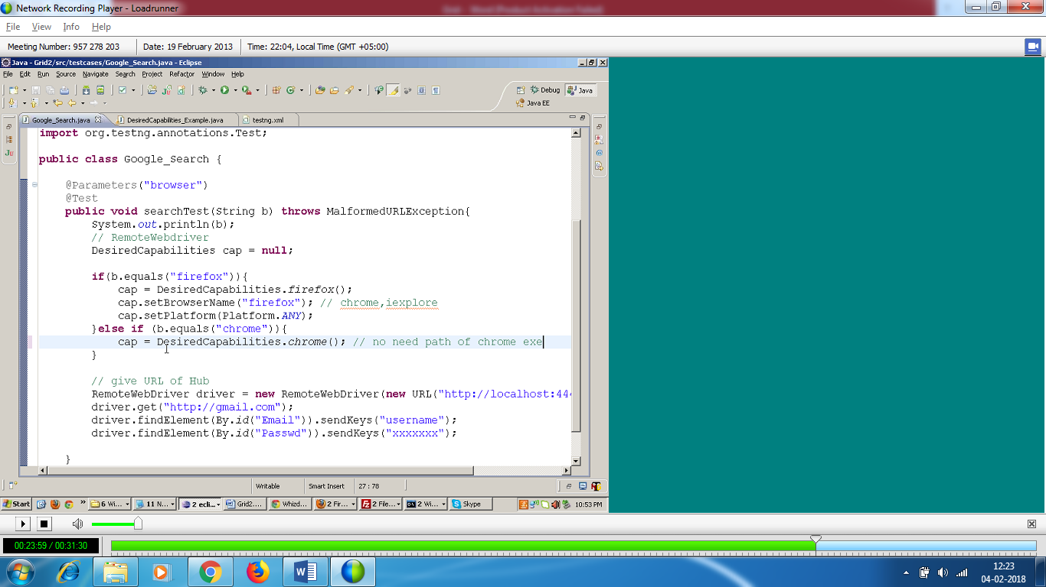

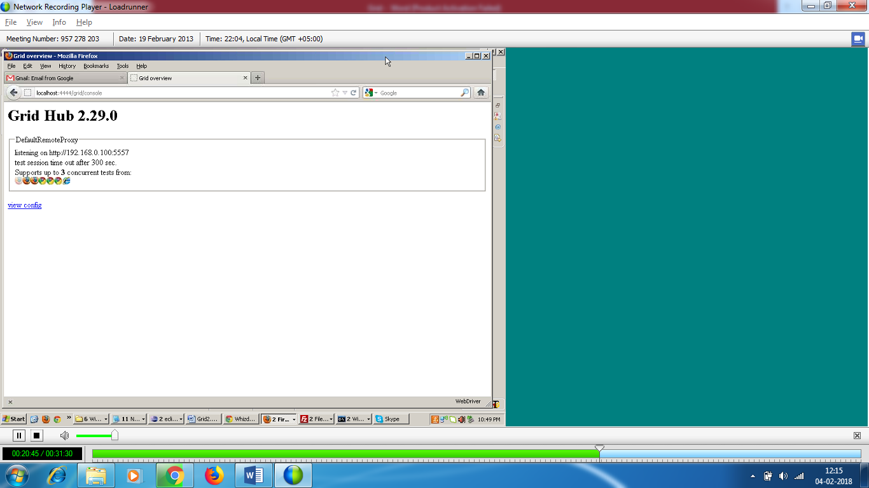

Set parameter in testing file.

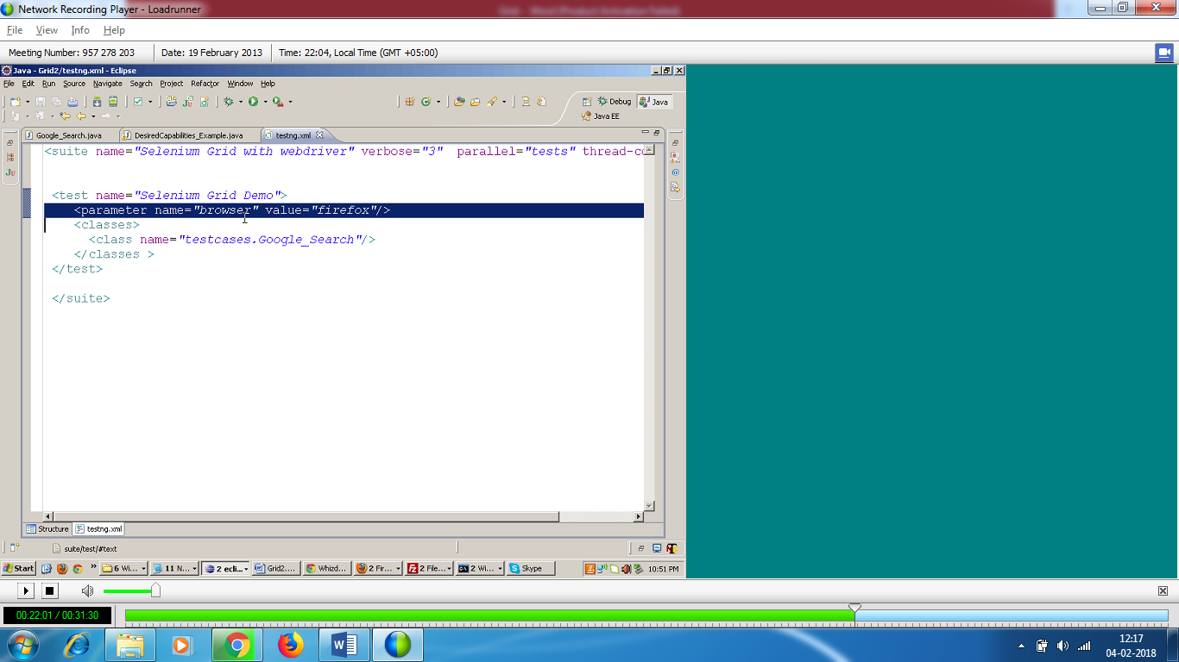



No need to give the path of chrome exe in code , because in grid file , we have given the exe path.

Change the parameter to chrome.

It will run on chrome.

Parameter is not good solution because we need to give the test cases 3 times in testing file for (IE , Chrome and ff)

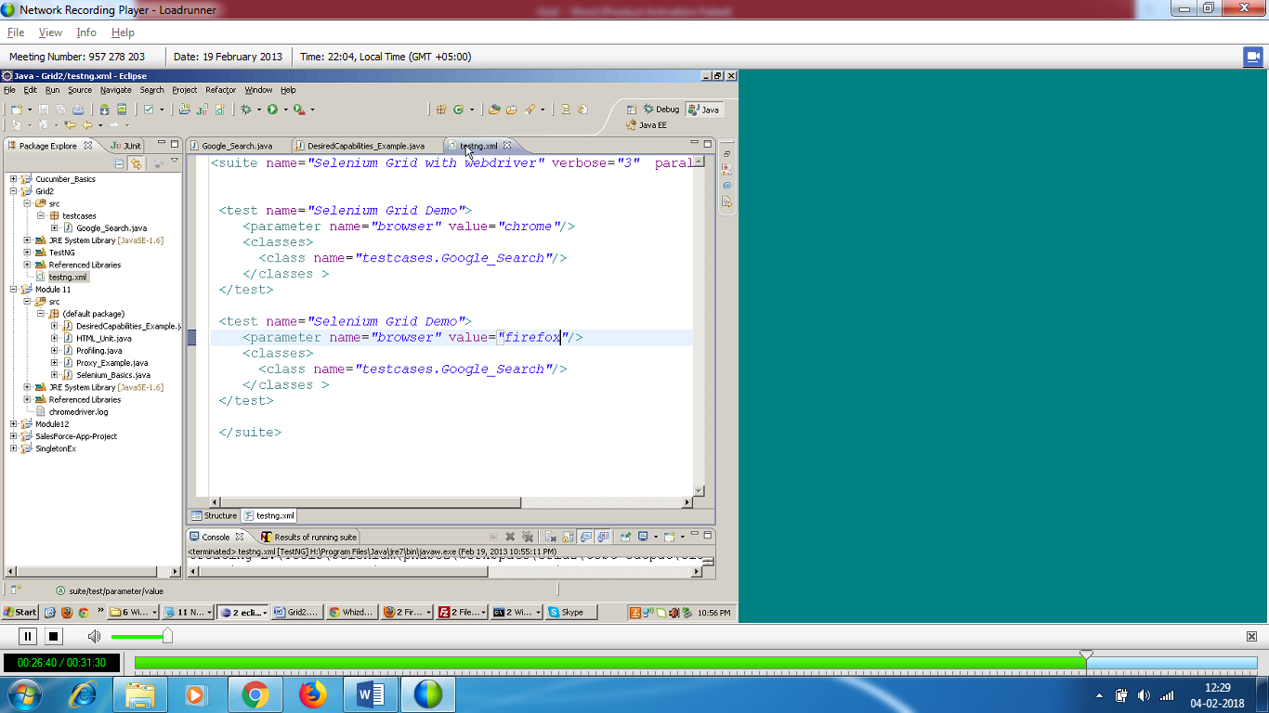

In testing Parallel -= “tests” and thread-count=”2”

The TestNG class will call the google test case parallely.

Thread count 2 – 2 test cases should be run parallely at a time.

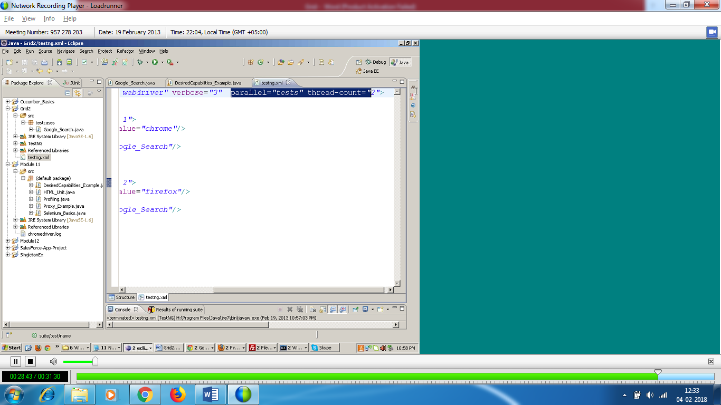

Without parameter you need to run the test in parallel

We need to use data provider to run the test in parallel.

This will run serially

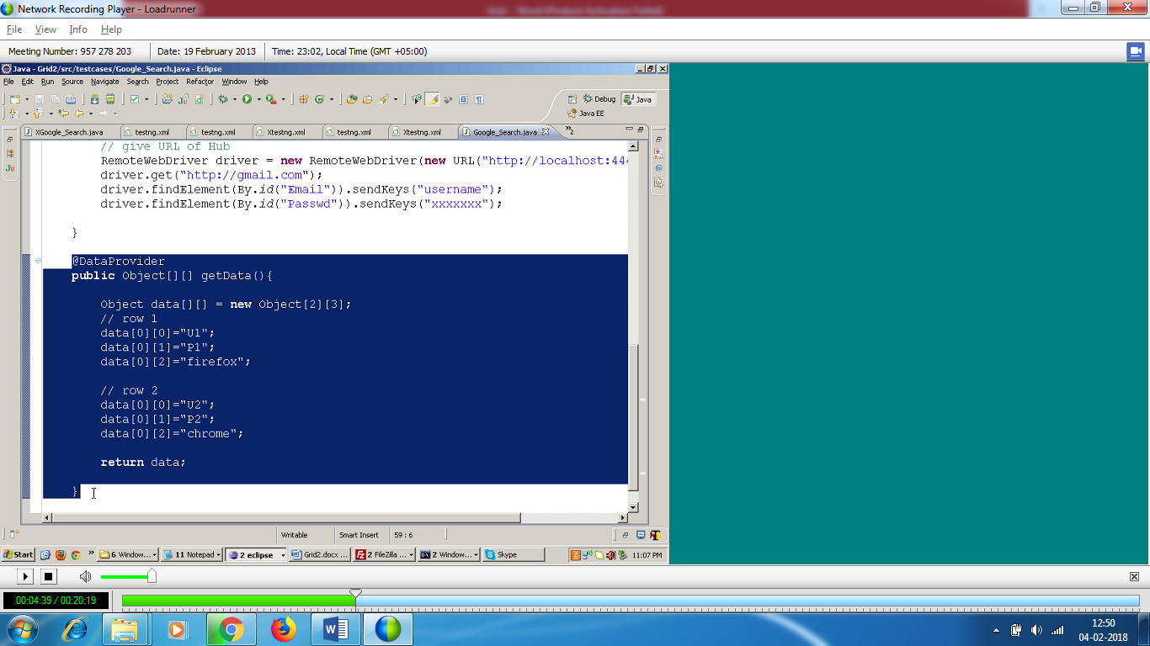

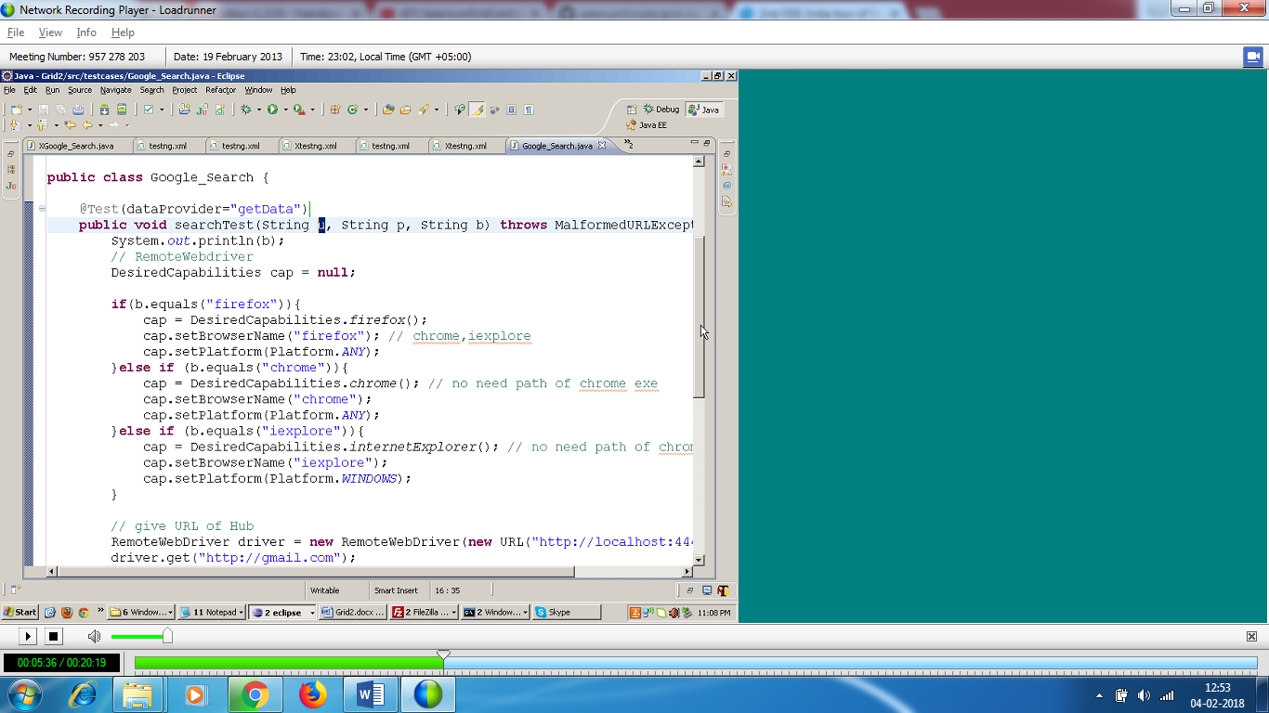

If I have to run the test cases parallely , I need to give the command

@DataProvide(parallel=true)

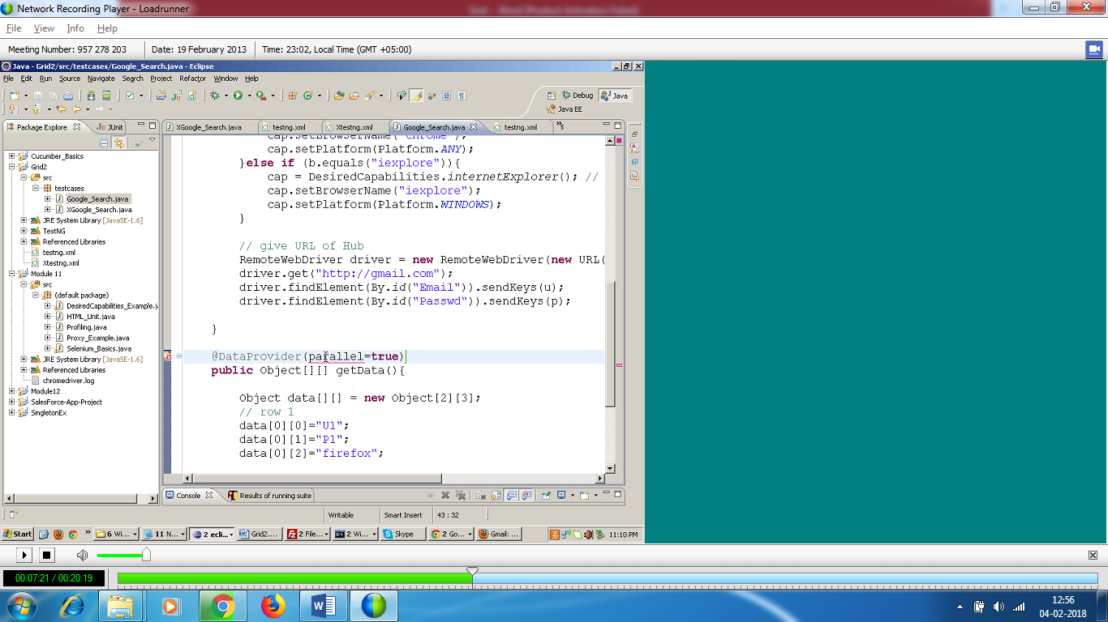

You see ff and chrome are greyed out . At one time max 3 browsers can execute.

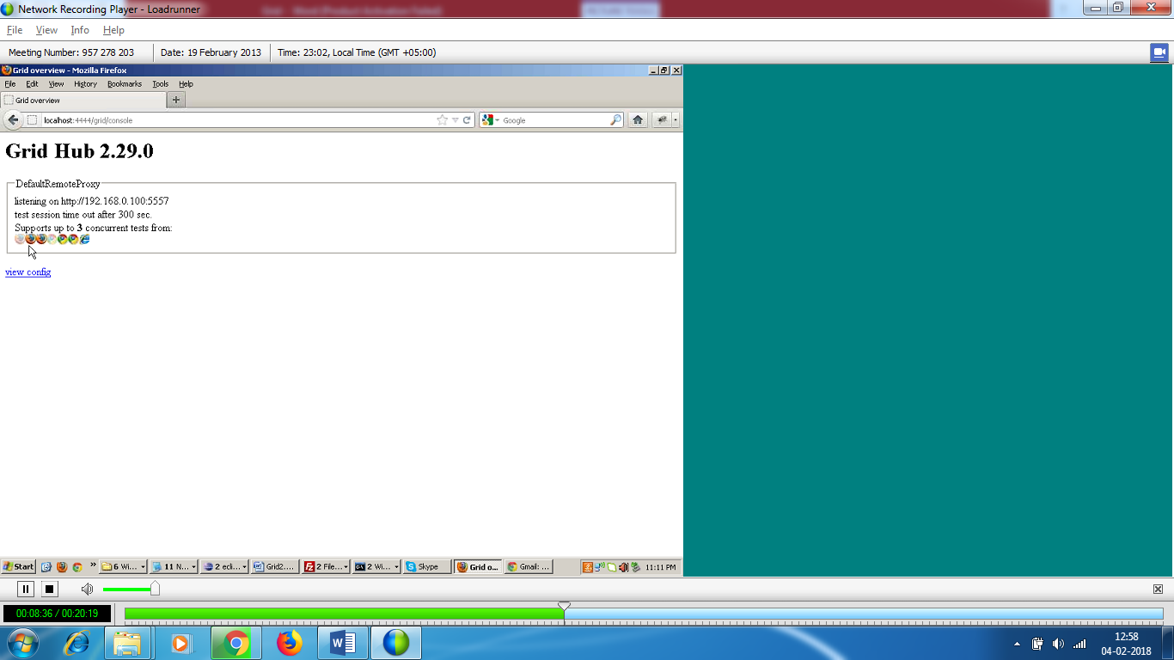

TEST CASE : 2

* I will execute on 4 ff and 4 chrome browsers . Add additional test cases in data provider.

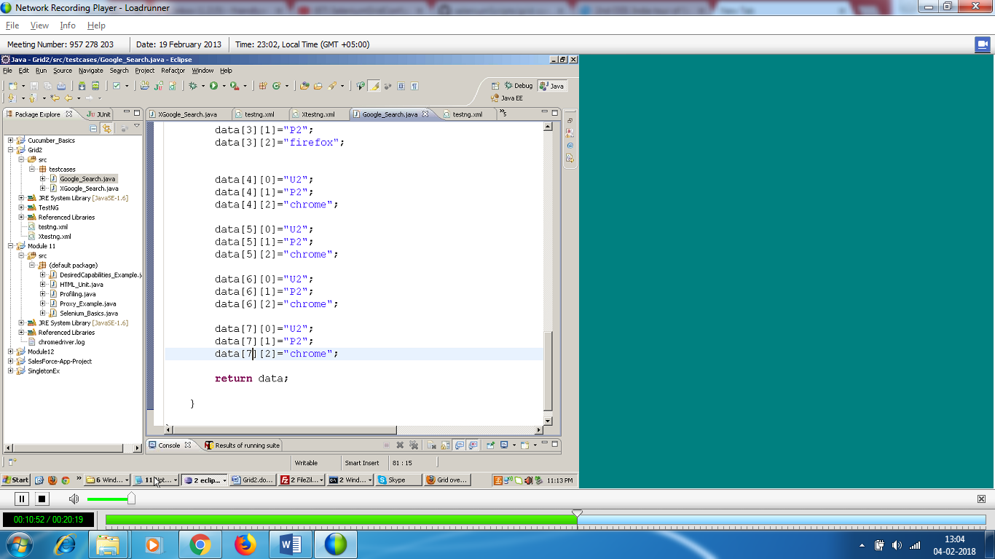

At one time only 3 browsers can execute as per hub

My test data 4 ff and 4 chrome

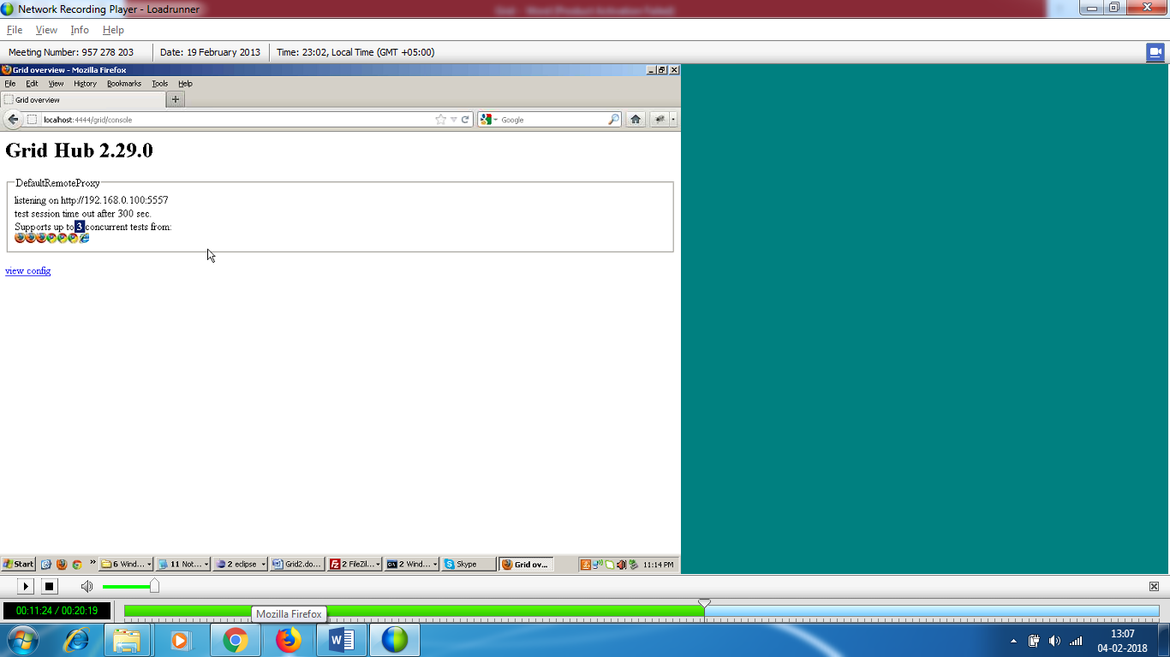

3 browsers will be greyed out.

TEST CASE : 3

Same test on multiple node

2 test case : ff and chrome

1 node : 1 FF browser

1 node : 1 chrome browser

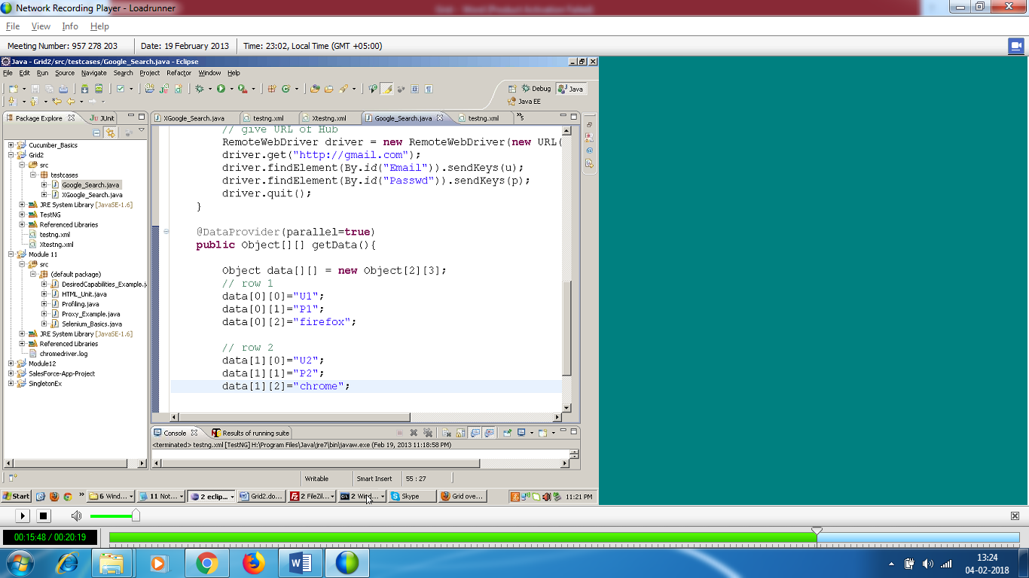

**Node 1 C:\>Java –Dwebdriver.chrome.driver=H:\chromedriver.exe -jar selenium-server-standalone-2.29.0.jar –role webdriver –hub (space)** [**https://localhost:4444/grid/register -port 5556**](https://localhost:4444/grid/register%20-port%205556) **-browser browserName=firefox,-maxinstance=2 -browser browserName=chrome,-maxinstance=3 –browser browserName=iexplore,-maxinstance=1 –maxsession 3**

**Node 2 C:\>Java –Dwebdriver.chrome.driver=H:\chromedriver.exe -jar selenium-server-standalone-2.29.0.jar –role webdriver –hub (space) https://localhost:4444/grid/register -port 55567 -browser browserName=firefox,-maxinstance=2 -browser browserName=chrome,-maxinstance=3 –browser browserName=iexplore,-maxinstance=1 –maxsession 3**

* Start hub
* Create 2 nodes with different port nos

It will pick free browsers on each node.

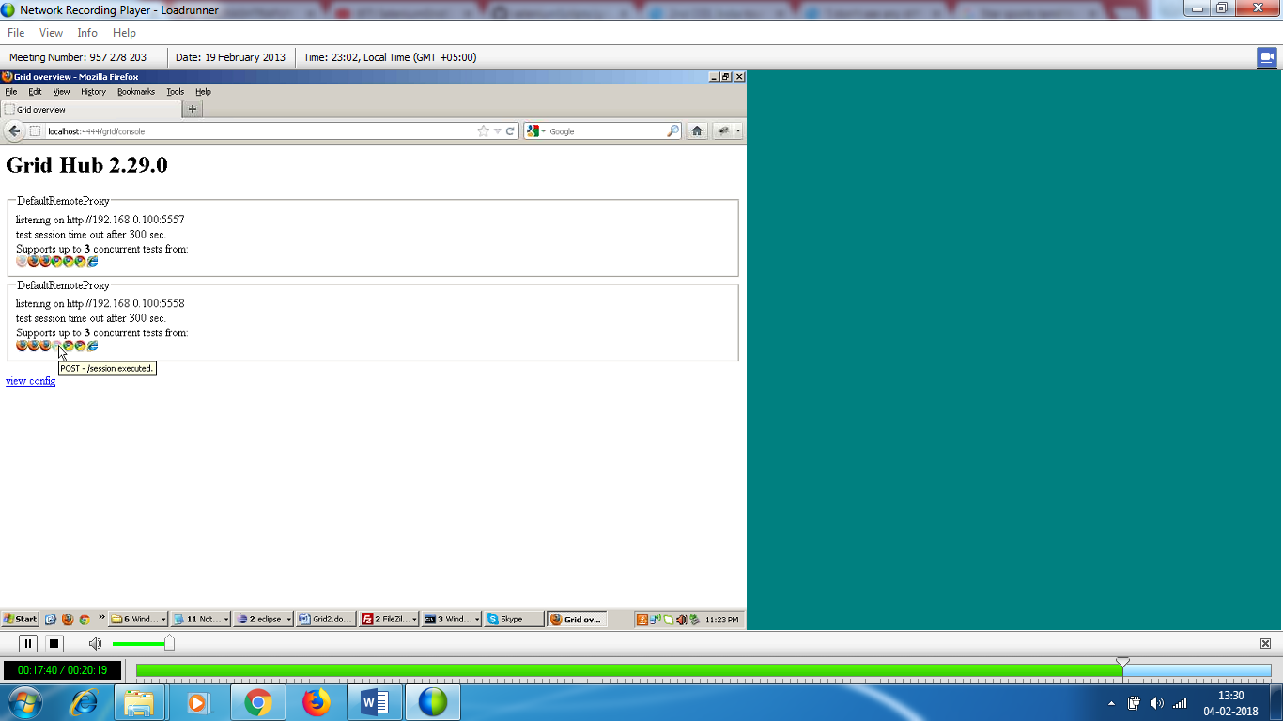

If I want node 1 should pick up ff test case and node 2 should pick chrome test case , then hae only ff browser on node 1 and chrome browser on node 2 .

3 test cases – 3 browsers on Node 1 - > I can run parallel

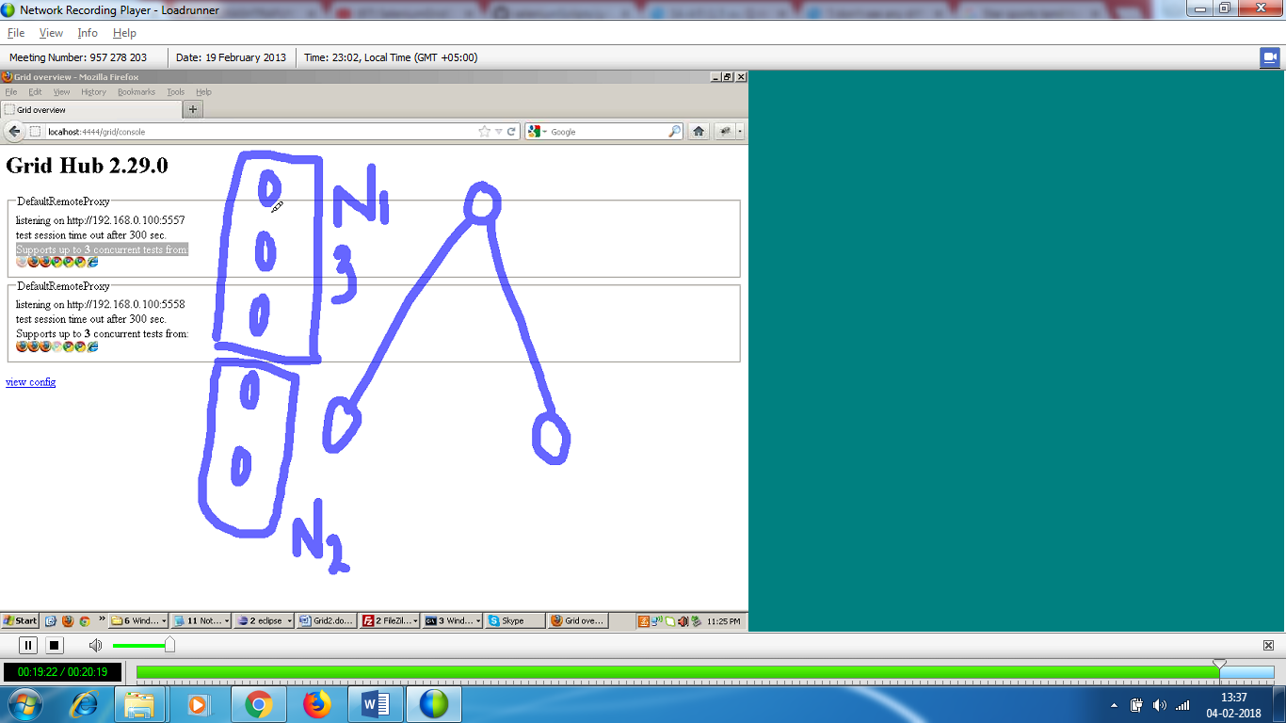

3 test cases serially - I can have 1 browser

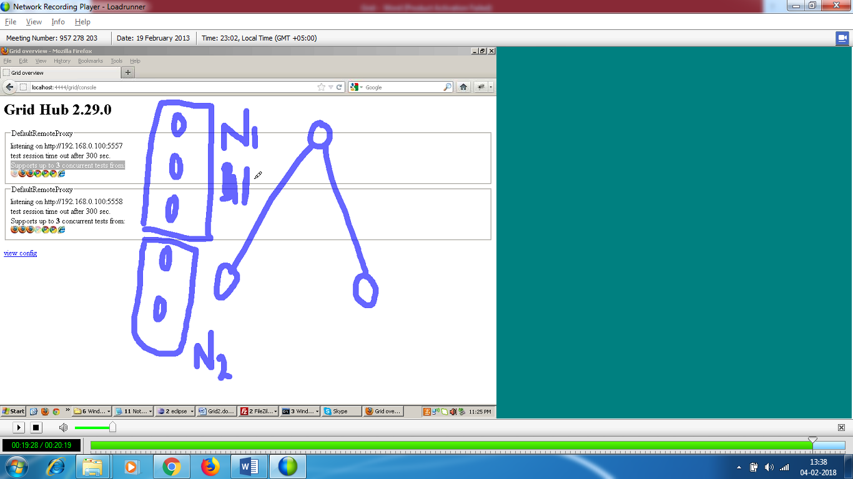

How to configure JSON file for hub and each node instead of commands

How do I start a hub and tell hub that read properties from json file.

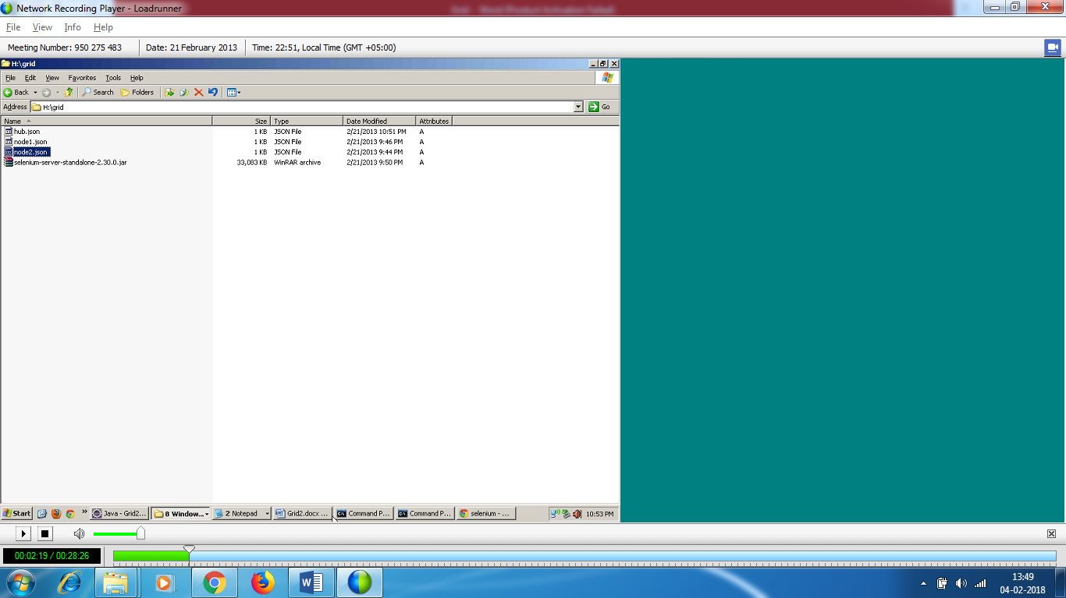

* **To start a hub:**

**C:\>java –jar selenium-server-standalone-2.29.0.jar – role hub –hubconfig hub.json**

**By default ,hub starts on port 4444**

**Node**

**C:\>Java -jar selenium-server-standalone-2.29.0.jar –role rc –nodeconfig node1.json**

You have 1 ff and 1 chrome as per json

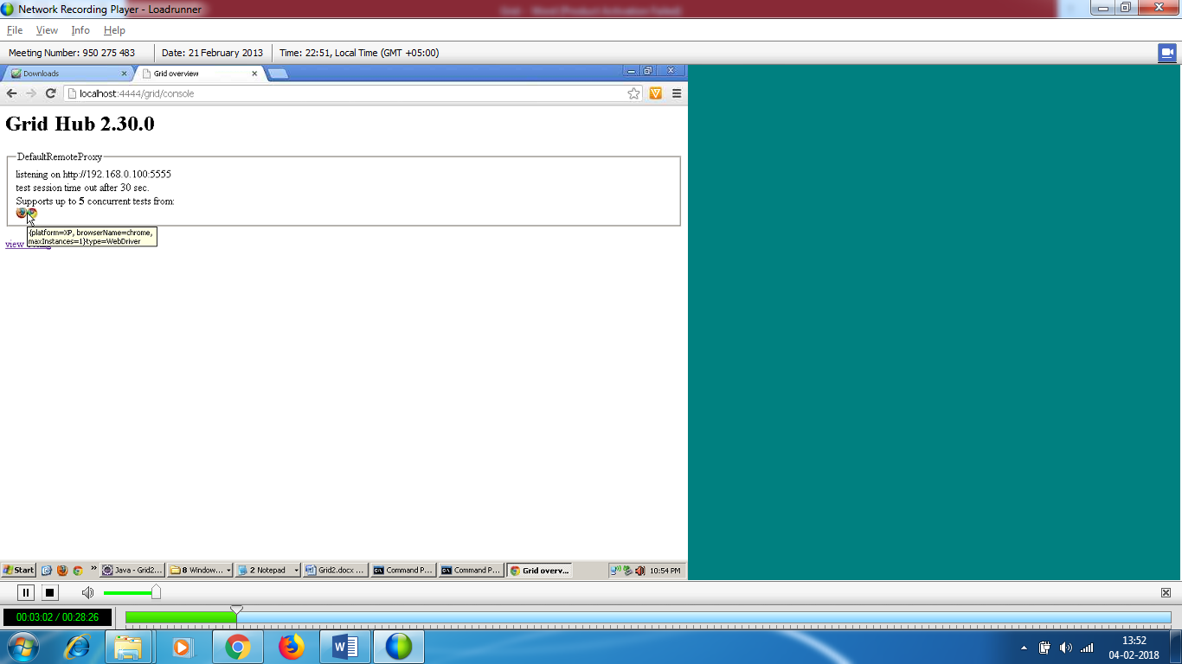

Node 1 json

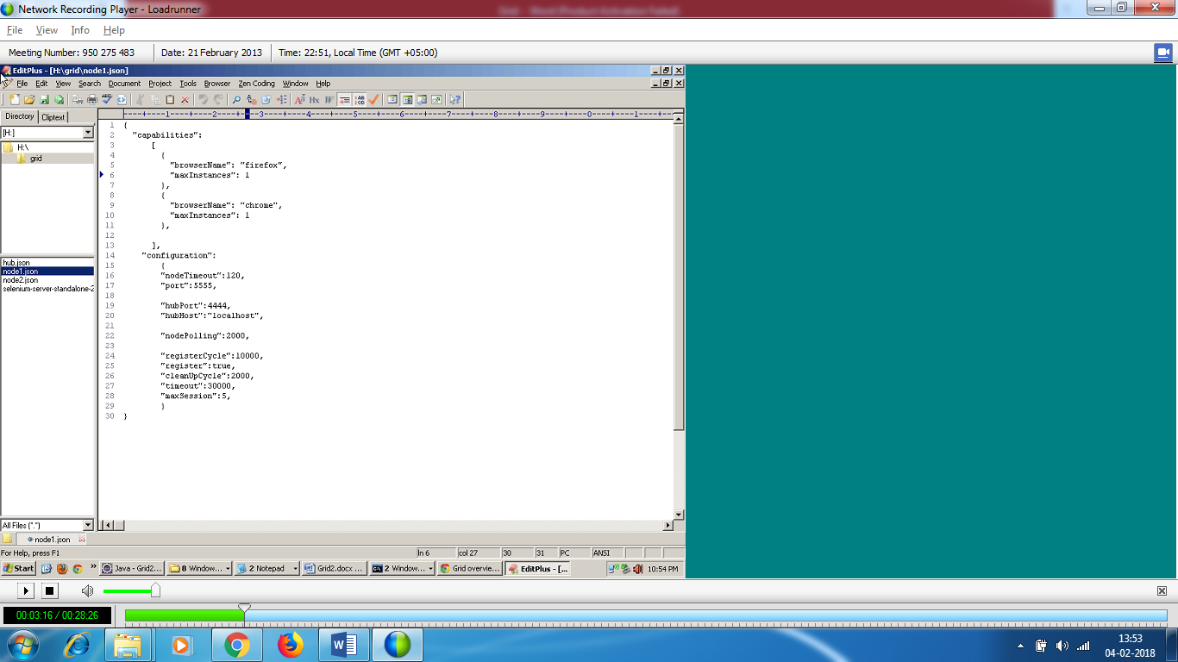

Node 2 JSON:

**C:\>Java -jar selenium-server-standalone-2.29.0.jar –role rc –nodeconfig node2.json**

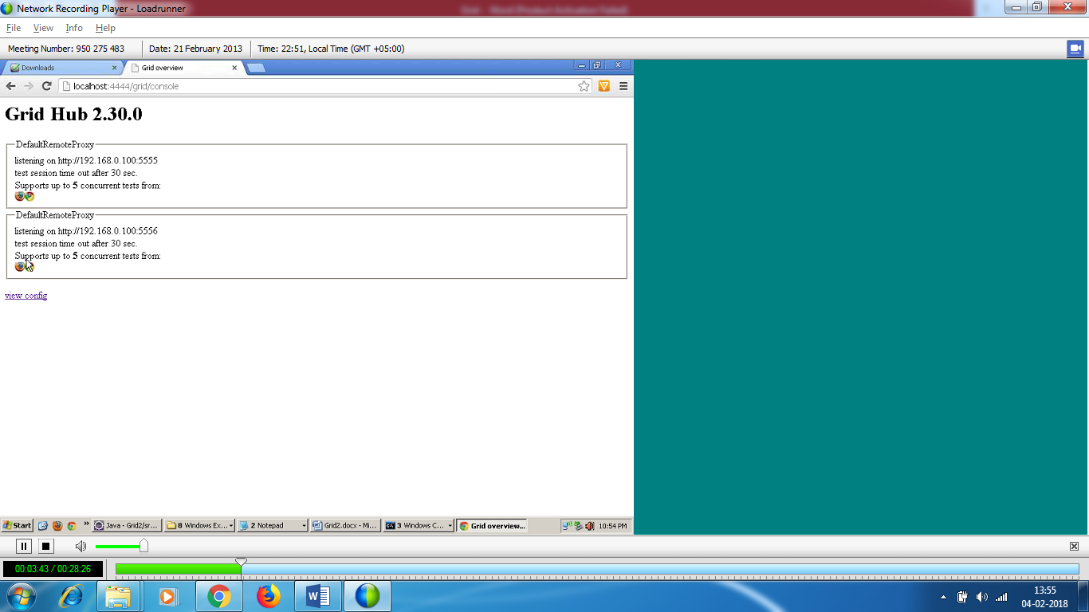

I was having a chat with one of the guy – grid developer

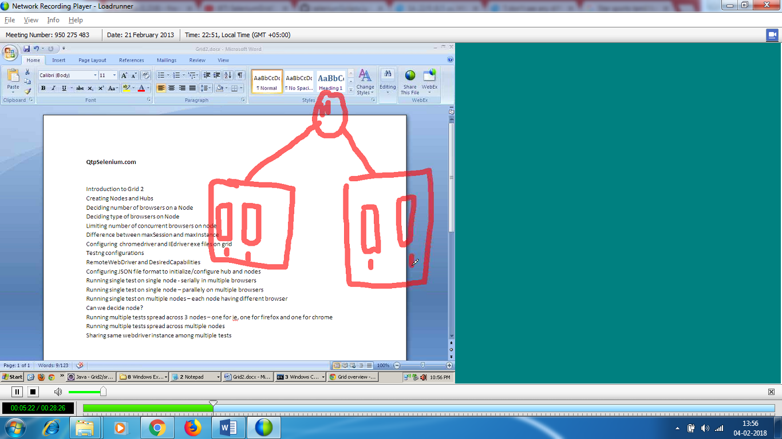

We have 4 nodes – Grid works the best – make one code with one pc.

Make one node per machine .

If you have got multiple test cases , A B C and all have ff test cases , and 2 nodes with each having one ff browser , you cannot assign test case A to be run on Node 1 like that

As soon as a grid finds node empty and it finds that it has test case in pipeline , then it assigns a node to that test case.

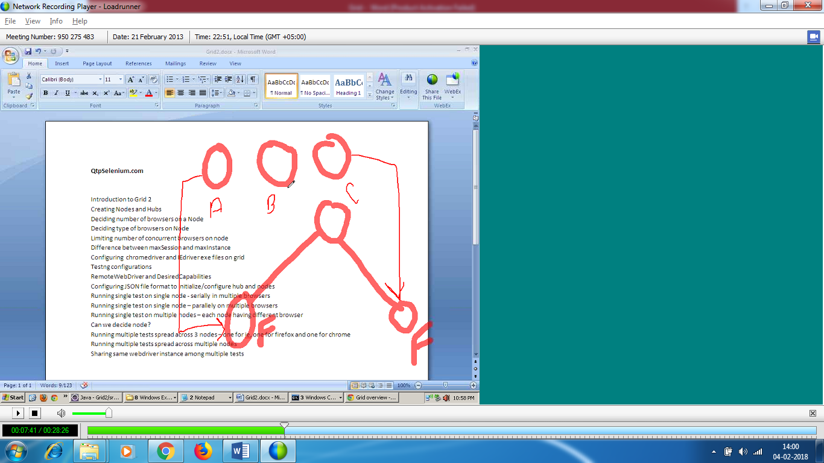



I have 100 test cases and all the test cases reach at the same time to hub and if test cases are to be executed in parallel , no test cases should be dependent on each other.

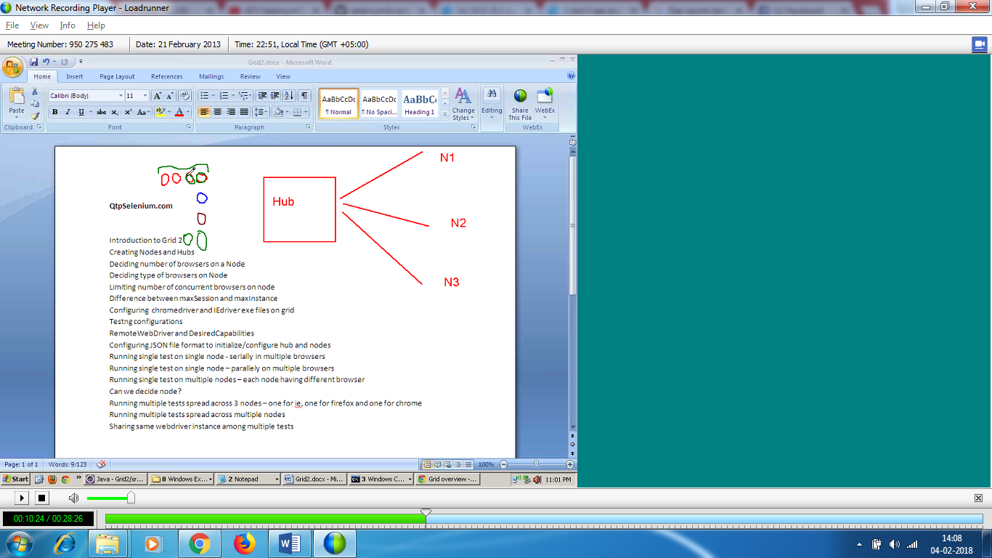  
Red , blue , brown and green test cases should be run in parallel

Red cases should be run in serially - I want the same browser to be used by these test cases – should stick to a node . Similarly green test cases .

Green test cases should be run in serially

I cannot tell hub to execute red cases in one node ( say A).



TEST CASE 4

Multiple test cases = Multiple class files

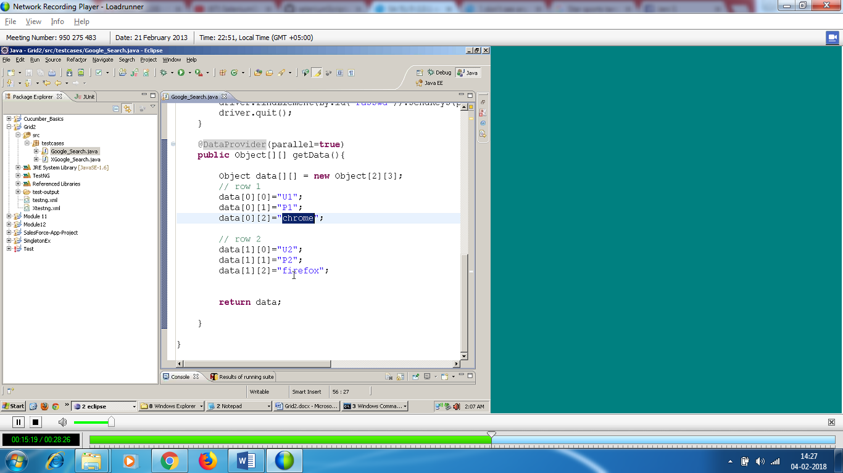

Another test – dropbox.com – Just enter the name

In testing test – I have given test=parallel , so it will run google test and dropbox test in parallel.

Both test (google test and drop box) have to be executed on different browsers.

Data test of both the test cases execute parallel.

So totally 4 tests wil run ( 2 on chrome and 2 on firefox)

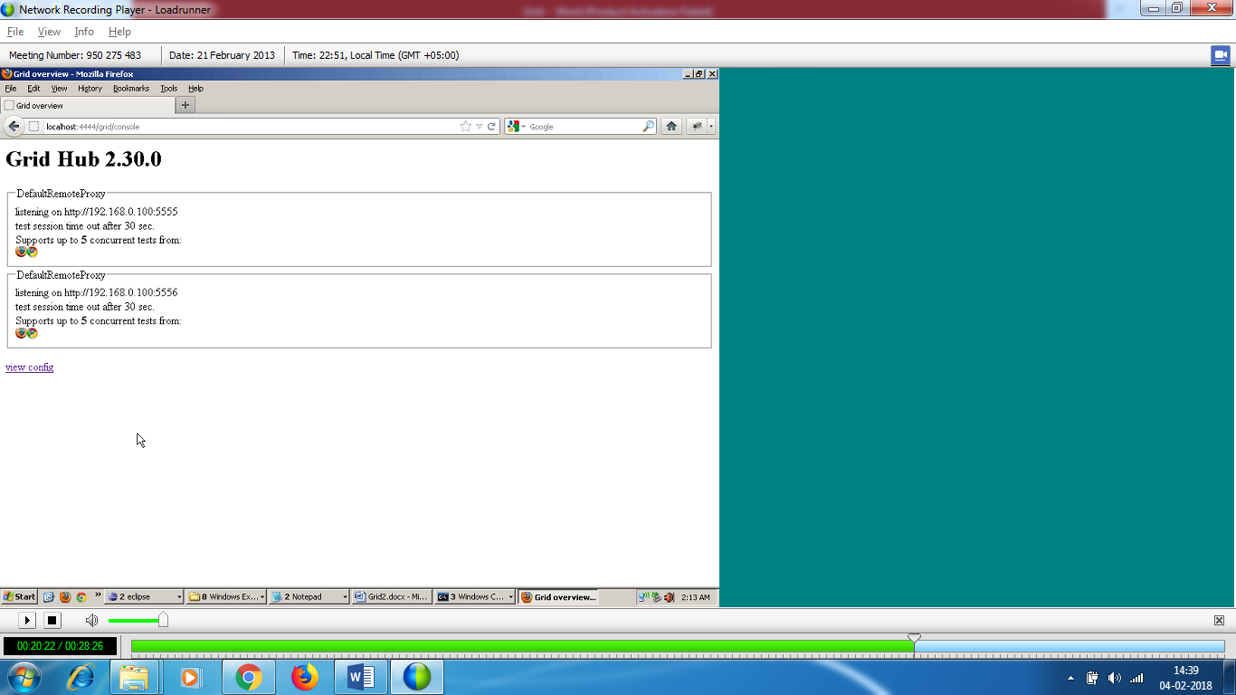

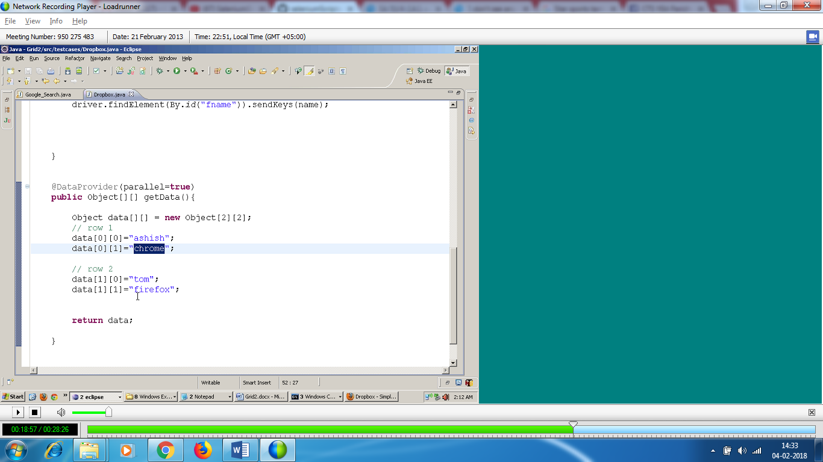

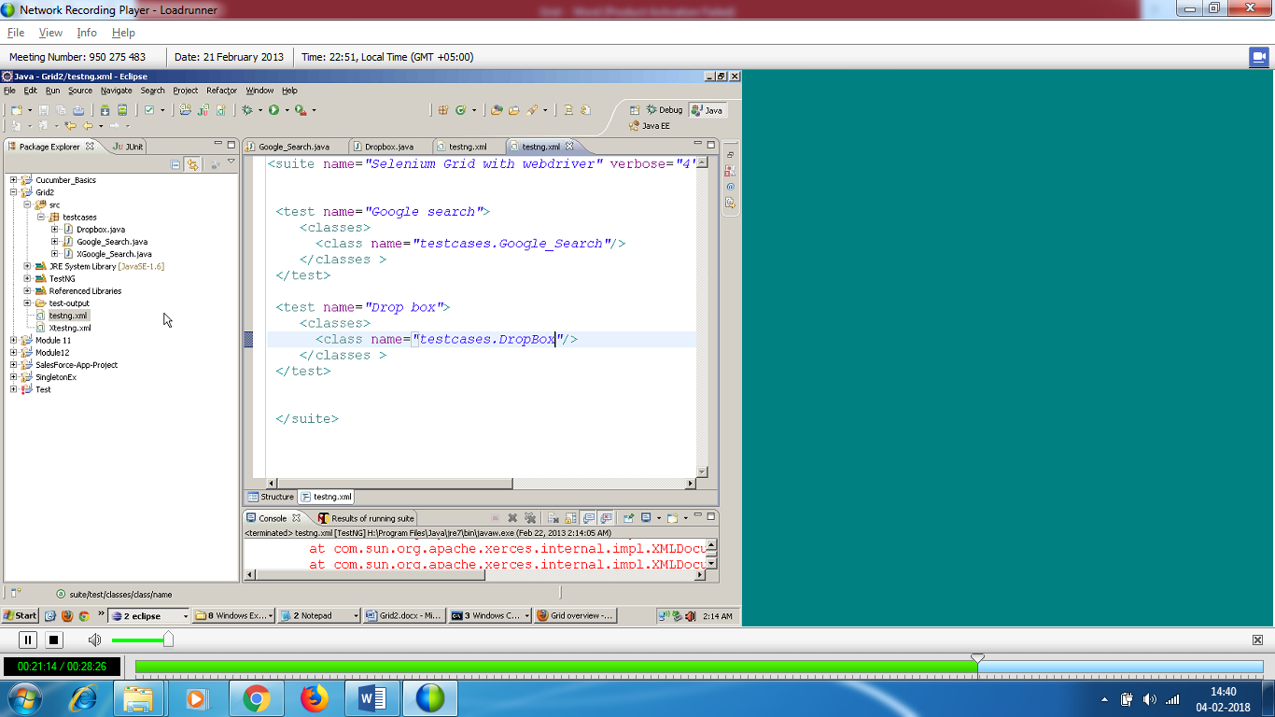

All 4 test cases start at once.

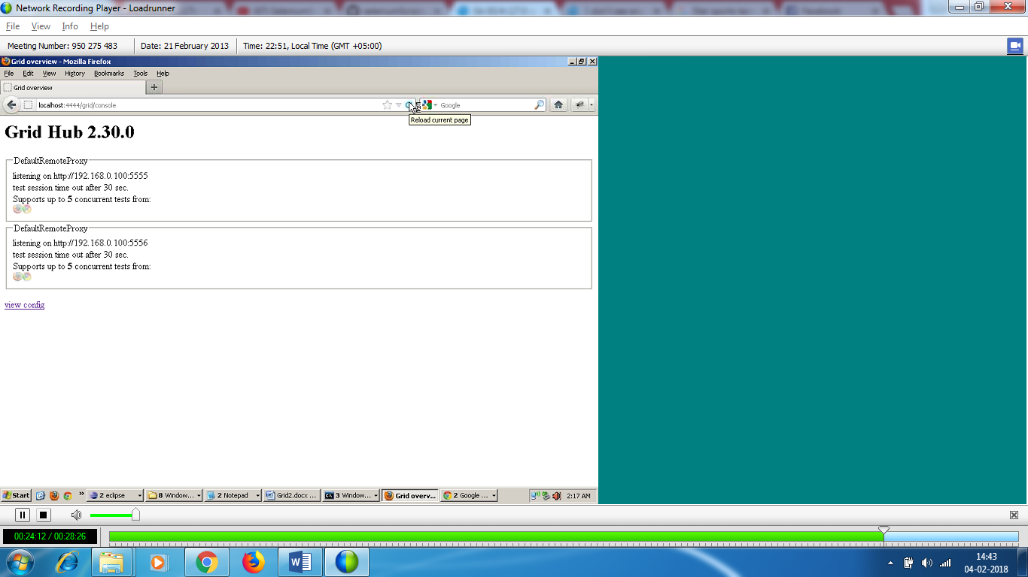

Suppose I keep on one node as ff and other node as chrome

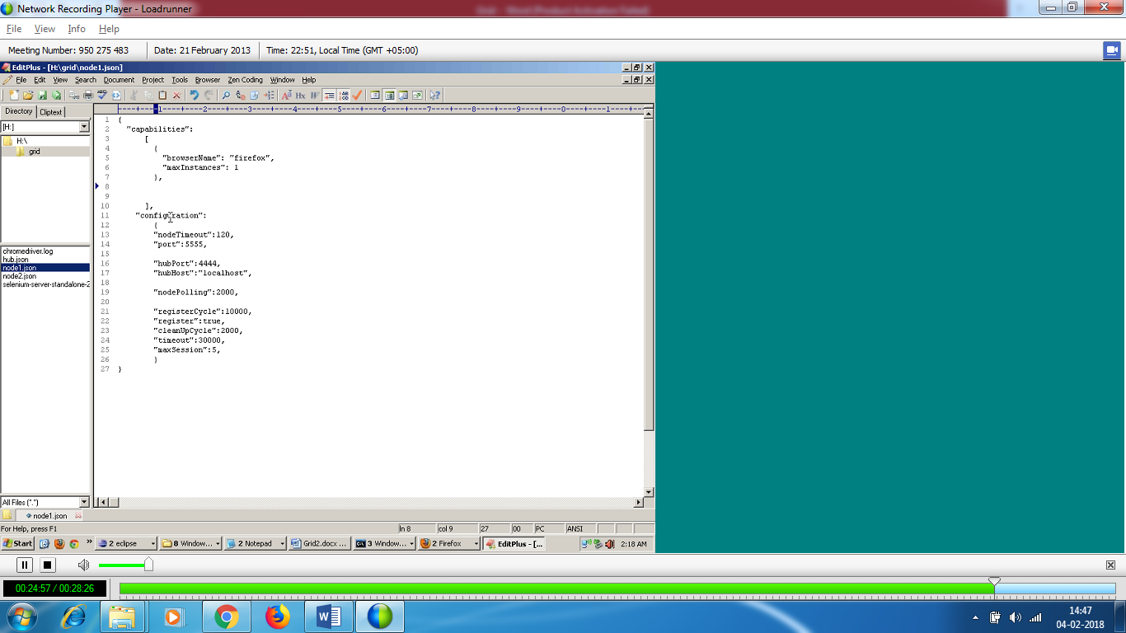

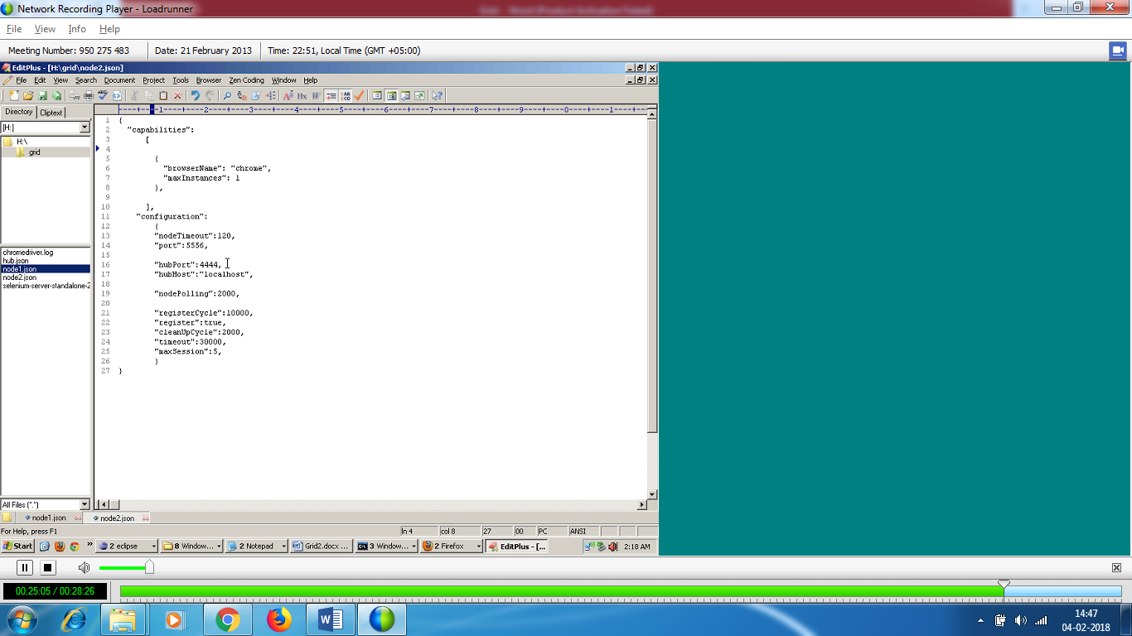

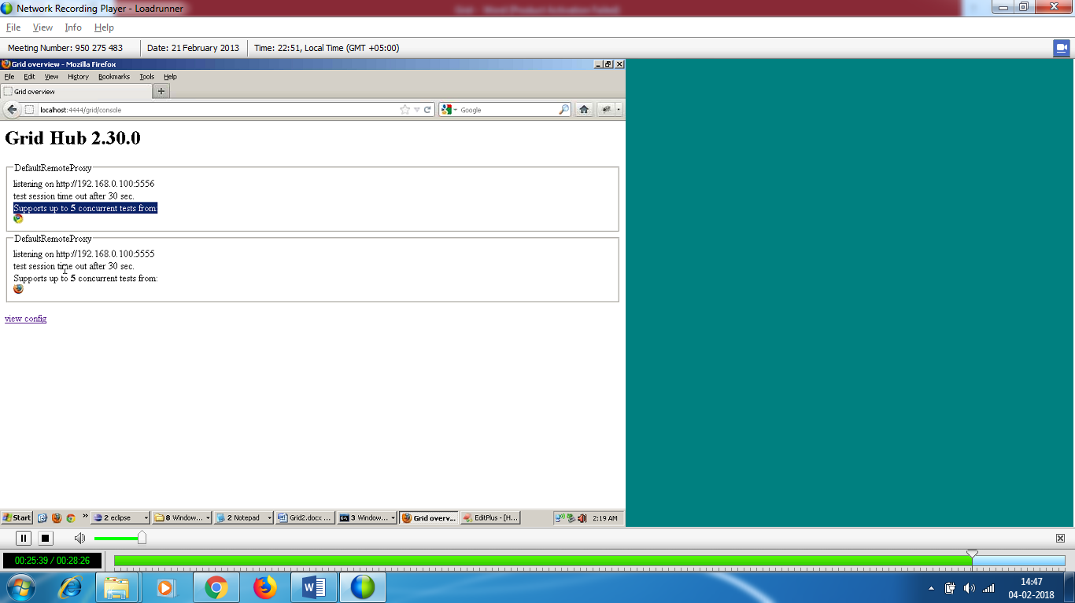

All 4 test will go to hub , although all 4 test cases have to be executed parallely,hub will say since I have only 1 browser in each node , it will run one after other ,after one test completes

I cannot specify which test case to run first.

We can set with priority on the test cases.

Video – 5

>It is testng with runs the test parallely not grid .

We create 3 test classes – Test A , Test B and Test C

Test A

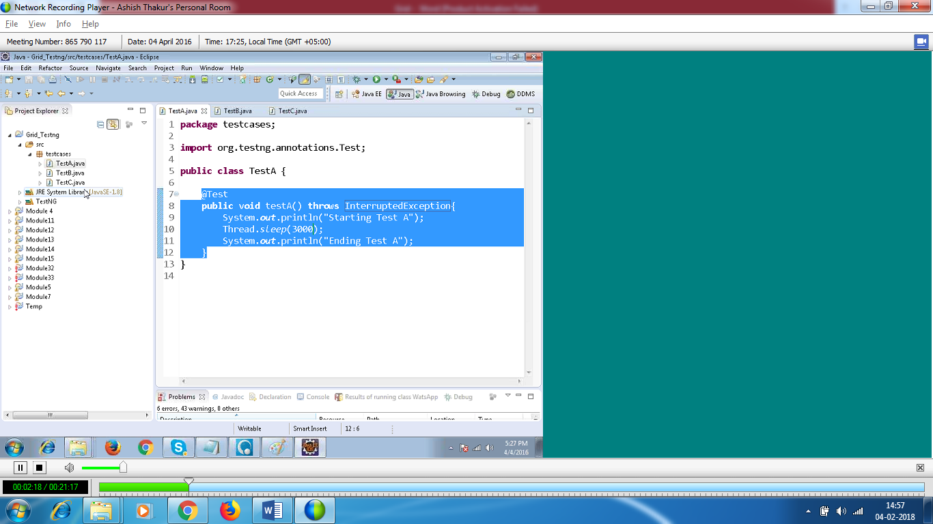

Test B :

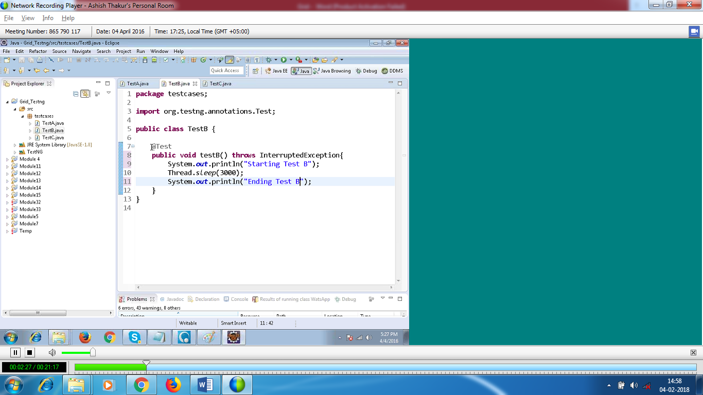

Test C :

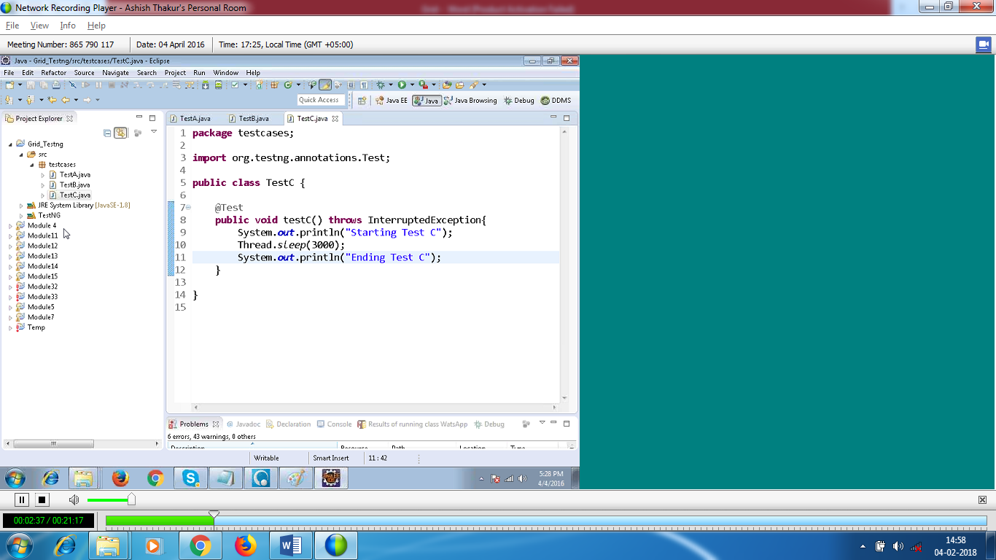

TestNG in serially (dont give parallel true)

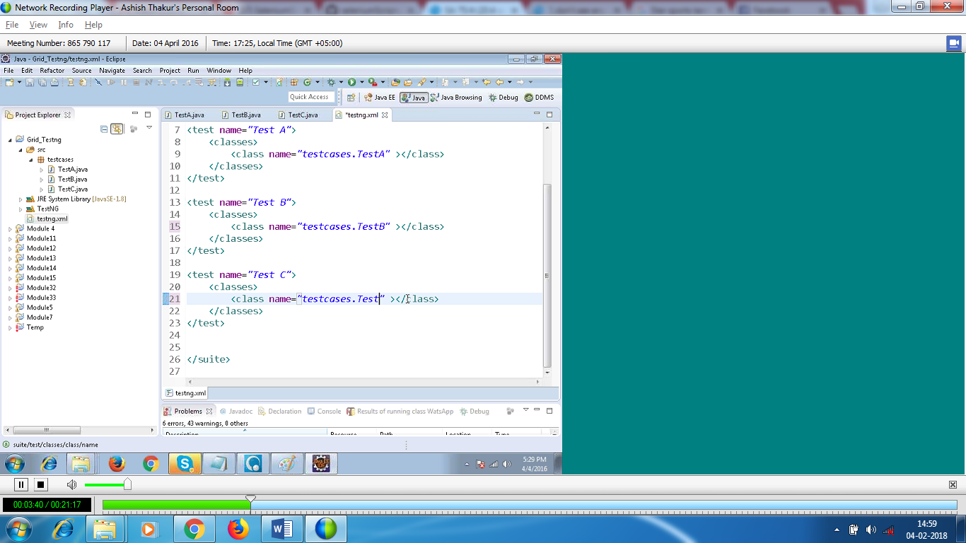

If you want to run parallely

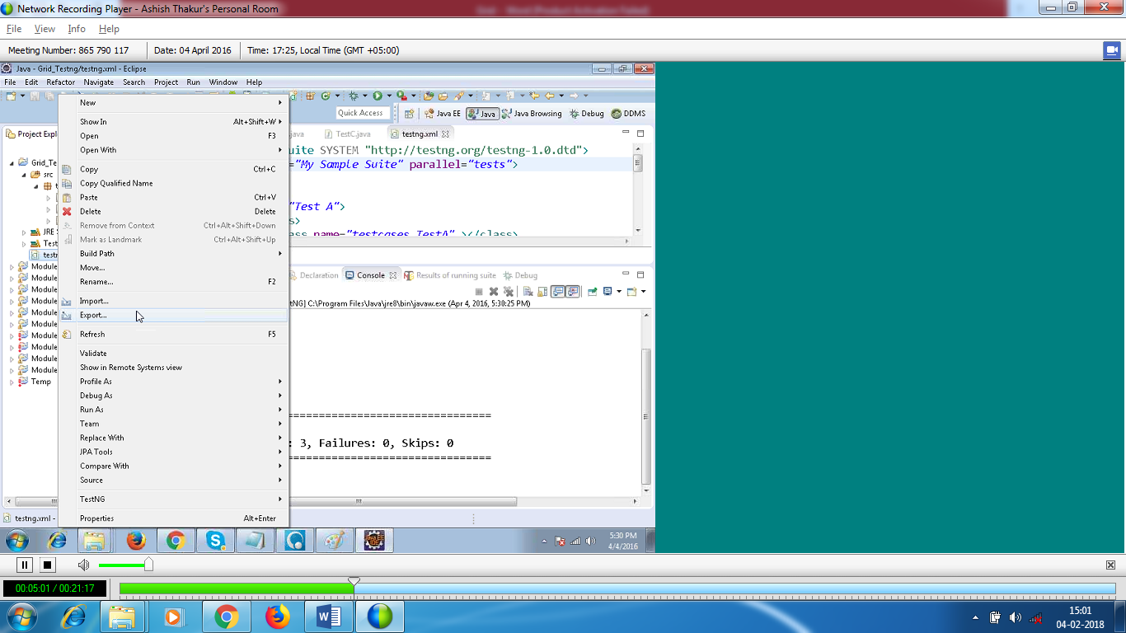

If I want to run the test parallel on single machine , then I don’t need grid . If I want to run them on multiple machines then I need grid.

It is hub which decides which test cases to be run on which machine.

Grid gives best results when you have one browser per node.If not execution speed delays a lot

HUB – json

Since I am running locally , host is null else I need to give ip address

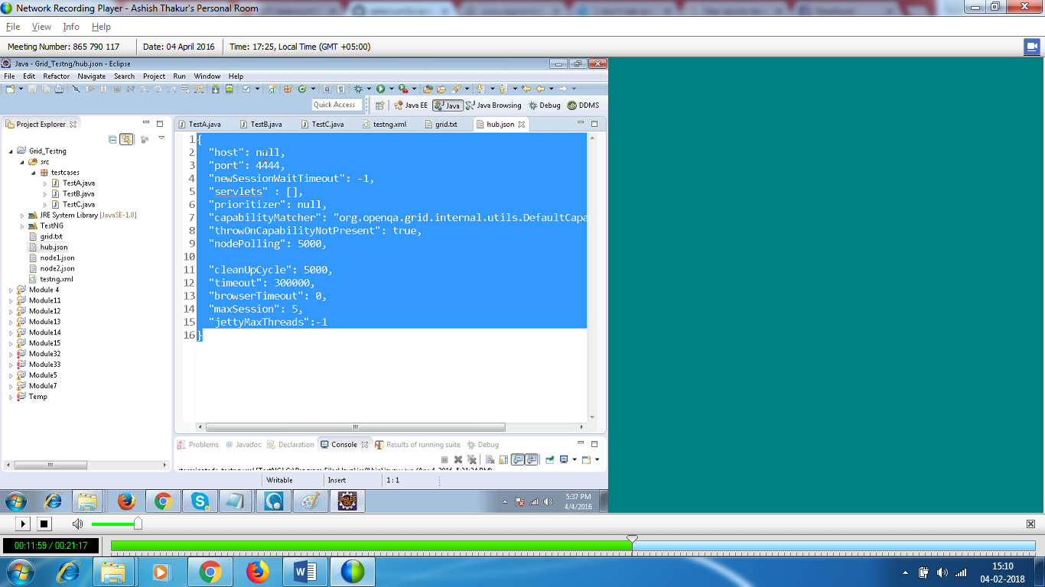

Node :

In host , you will give the IP address.

Hubhost – ip of the hub

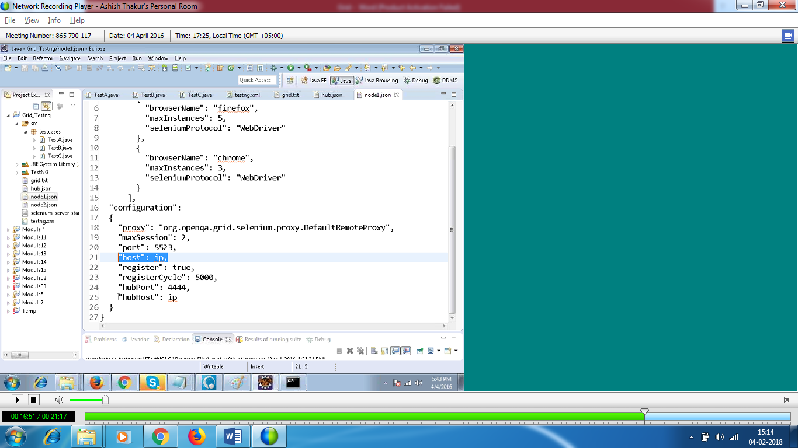

It is not the grid that executes the test parallely. If you want to run the tests parallely on single machine ,you can do with testng.

Grid has hub and node . Node means machines , HUB means centralized repository.

All the tests reach the bug parallely. TestNG executes the test parallely .All the tests reach the hub parallely . Hub decides on which node the testcase wil run.

In grid , you need to use driver.quit . you make the node to be available ,so that other test cases will use the node to run.

You need selenium standlone jar